25 Spring ECEN 610: Mixed-Signal Interfaces

Lab2: Signal to Noise Ratio, Quantization

Name: Yu-Hao Chen

UIN:435009528

Section:601

Professor: Sebastian Hoyos

TA: Sky Zhao

1. SIGNAL TO NOISE RATIO (40%) Generate a tone with frequency 2 MHz and amplitude 1 V. Sample the tone at frequencies Fs = 5 MHz.

a) Add Gaussian noise to the sampled sinewave such that the signal SNR is 50 dB. Find first the variance of the Gaussian noise needed to produce the target SNR. Calculate and plot the Power Spectral Density (PSD) from the DFT of the noisy samples. Corroborate that the SNR calculation from the DFT plot gives the theoretical result. What would be the variance of a uniformly distributed noise to obtain the same SNR.

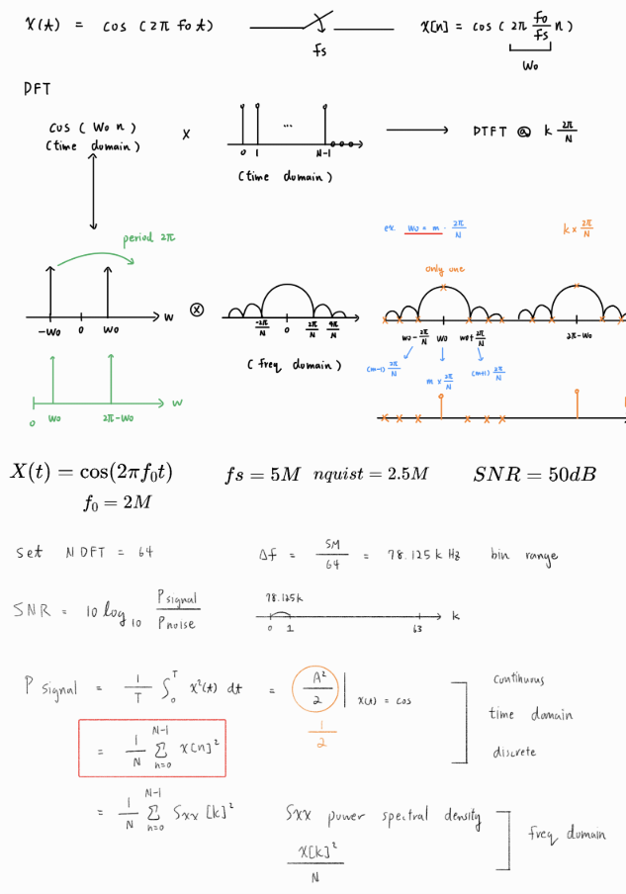

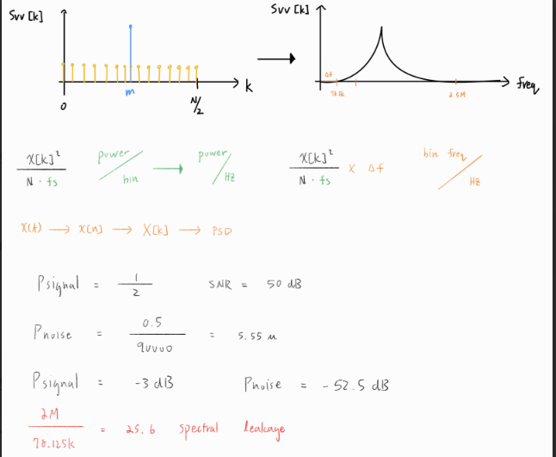

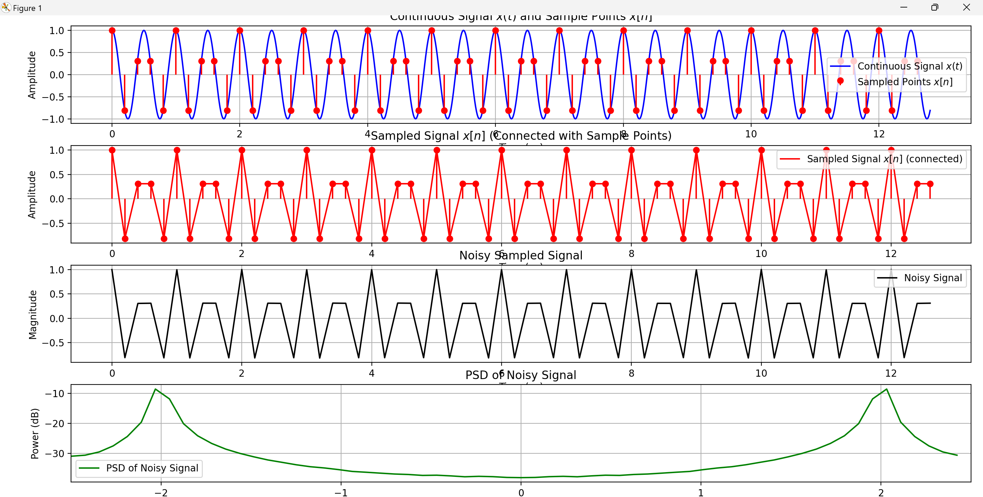

b) Now repeat a.) using a window before the DFT. Use the following windows: Hanning, Hamming, Blackman. What are your conclusions? NOTE: The use of windows mentioned above spreads the signal power. You must take this into account when computing SNR.

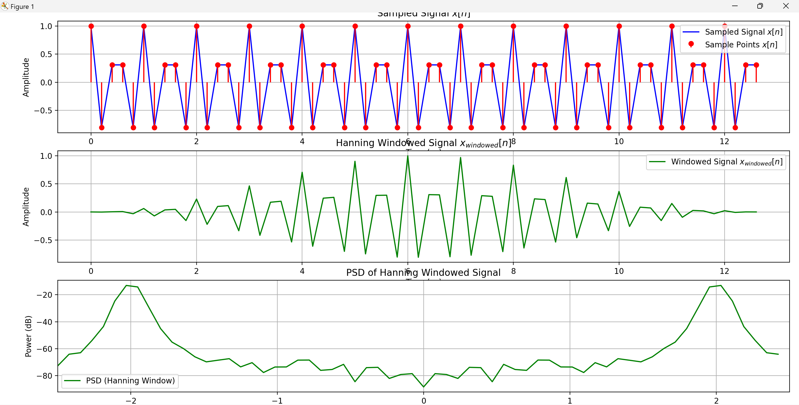

Hanning window

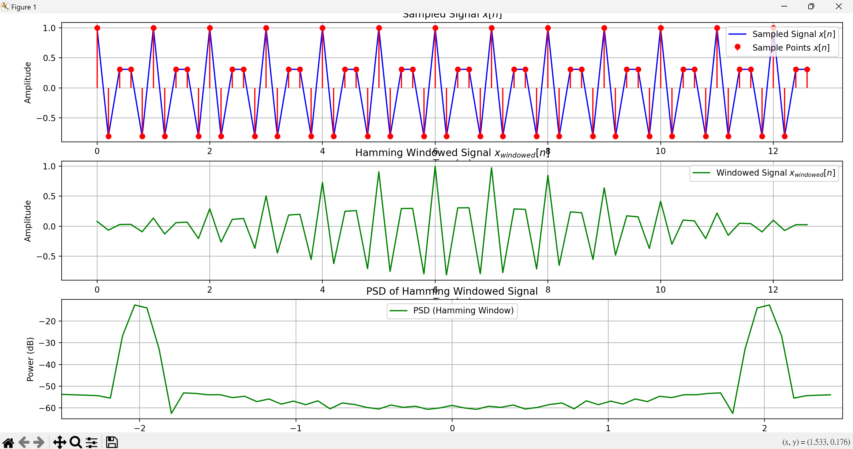

Hamming window

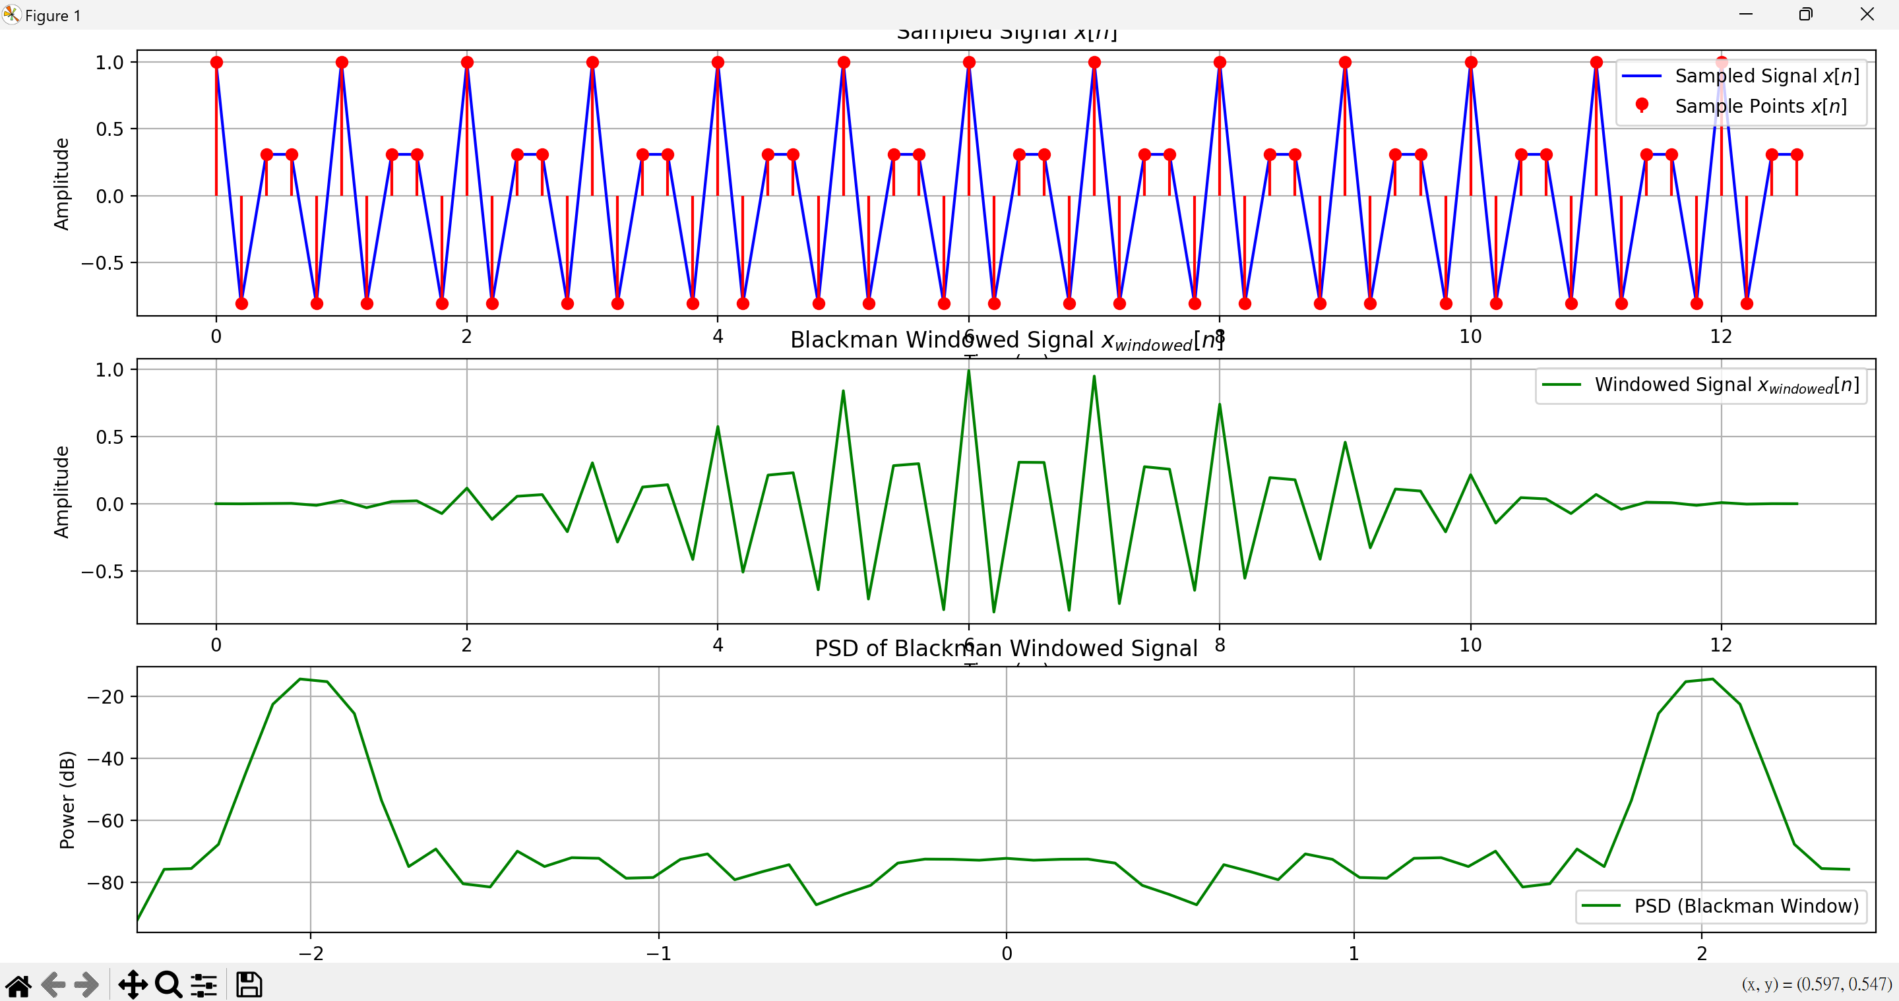

Blackman window

2. QUANTIZATION

1. Create a perfect quantizer with 6 bits of resolution and with flexible sampling rate. For a 200 MHz full scale input tone, sample and quantize the sinewave at 400 MHz and plot the PSD of 30 periods. What is the SNR? Repeat the SNR calculation for 100 periods of the same signal. Make your own conclusions about this test regarding periodicity of quantization noise and the impact of this in the SNR. How can you solve this problem?

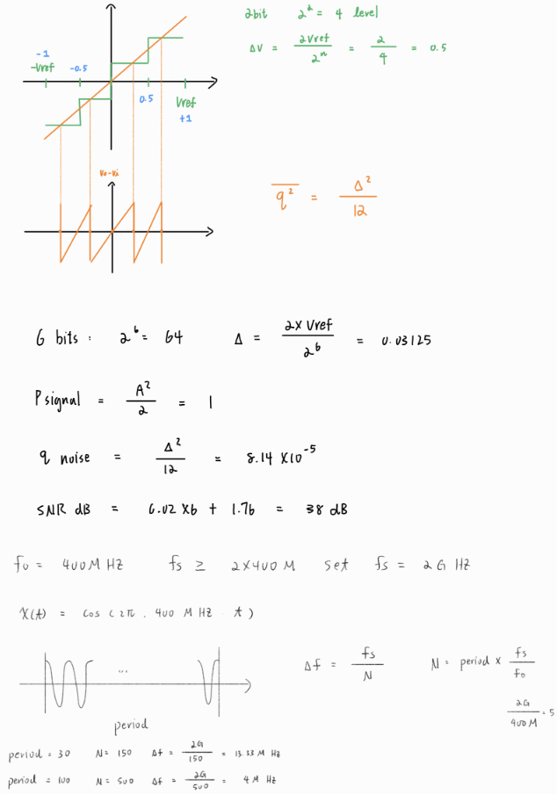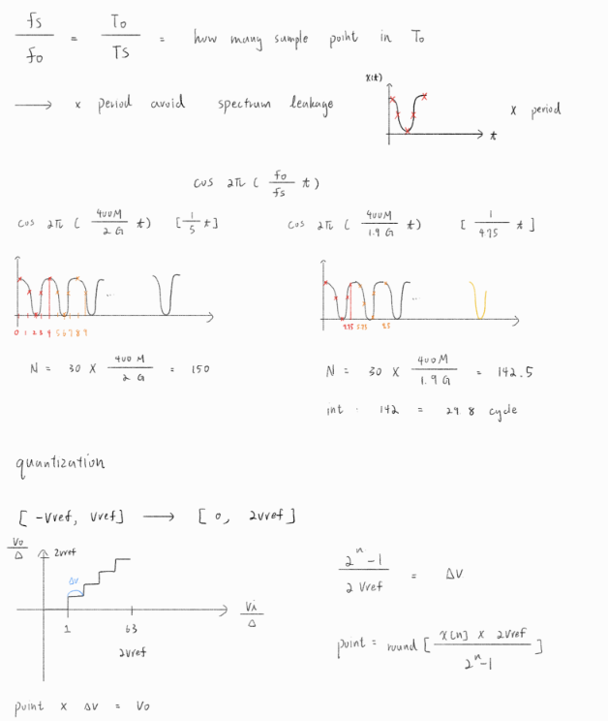

Ex: Fs= 2G, F0= 400M, cycle=30, Fs/F0=5

N=30*5=150, 150/5= 30cycle (periodic)

If sampling frequency Fs is **A times** the input signal frequency F0, this creates **periodic quantization error** because the sampling points repeat every Fs/F0 cycles. Periodic error accumulates at certain frequencies, causing **lower noise power** and an **artificially high SNR**. (quantization error distribution is not like a white noise)

Change NNN-DFT, period, or Fs to avoid sampling period being an integer multiple of the signal period.

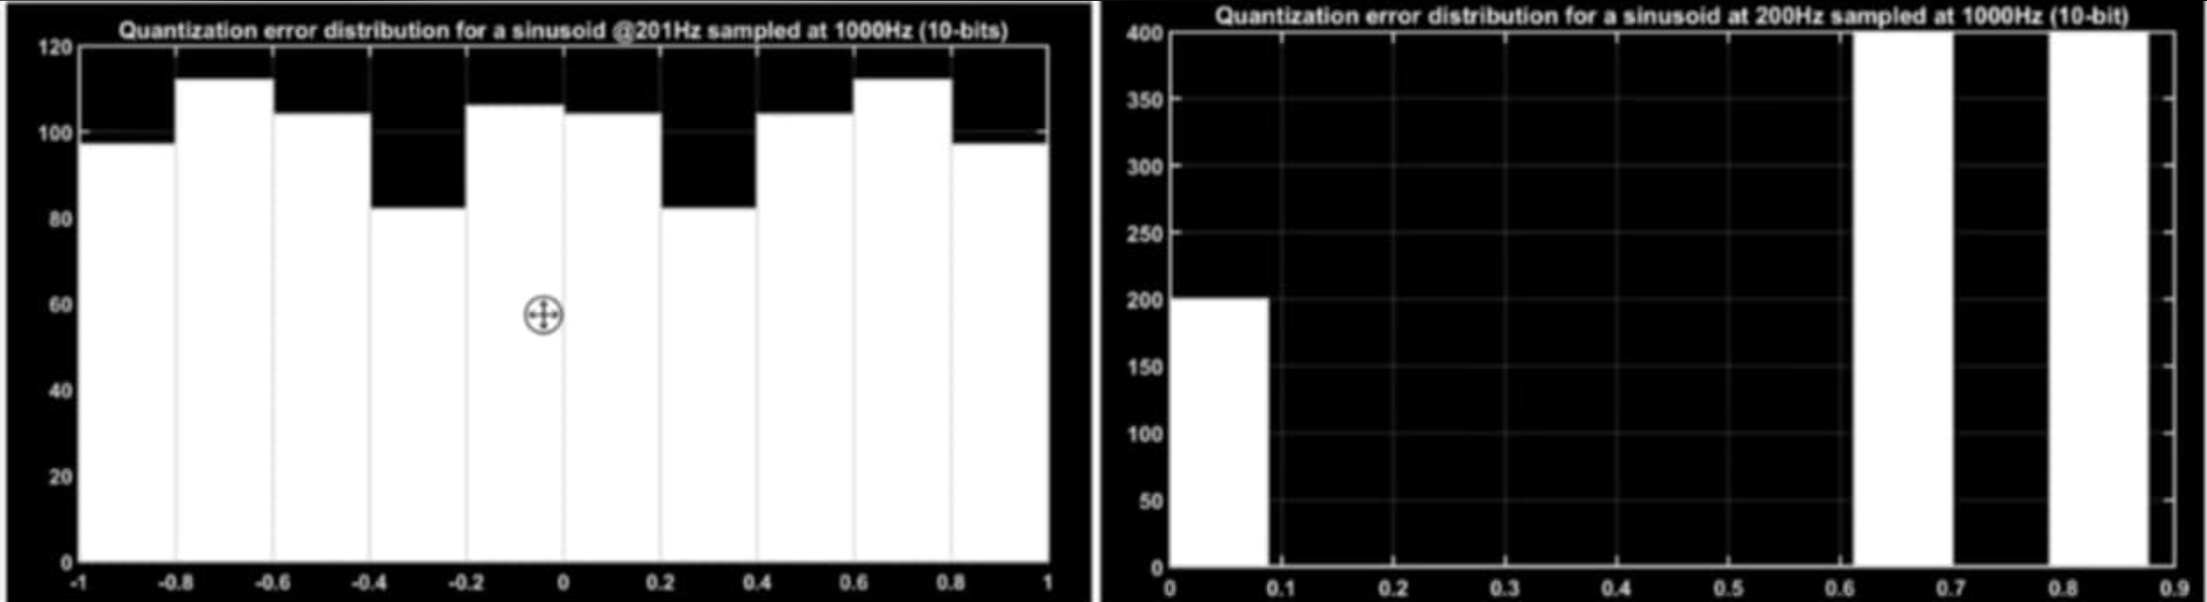

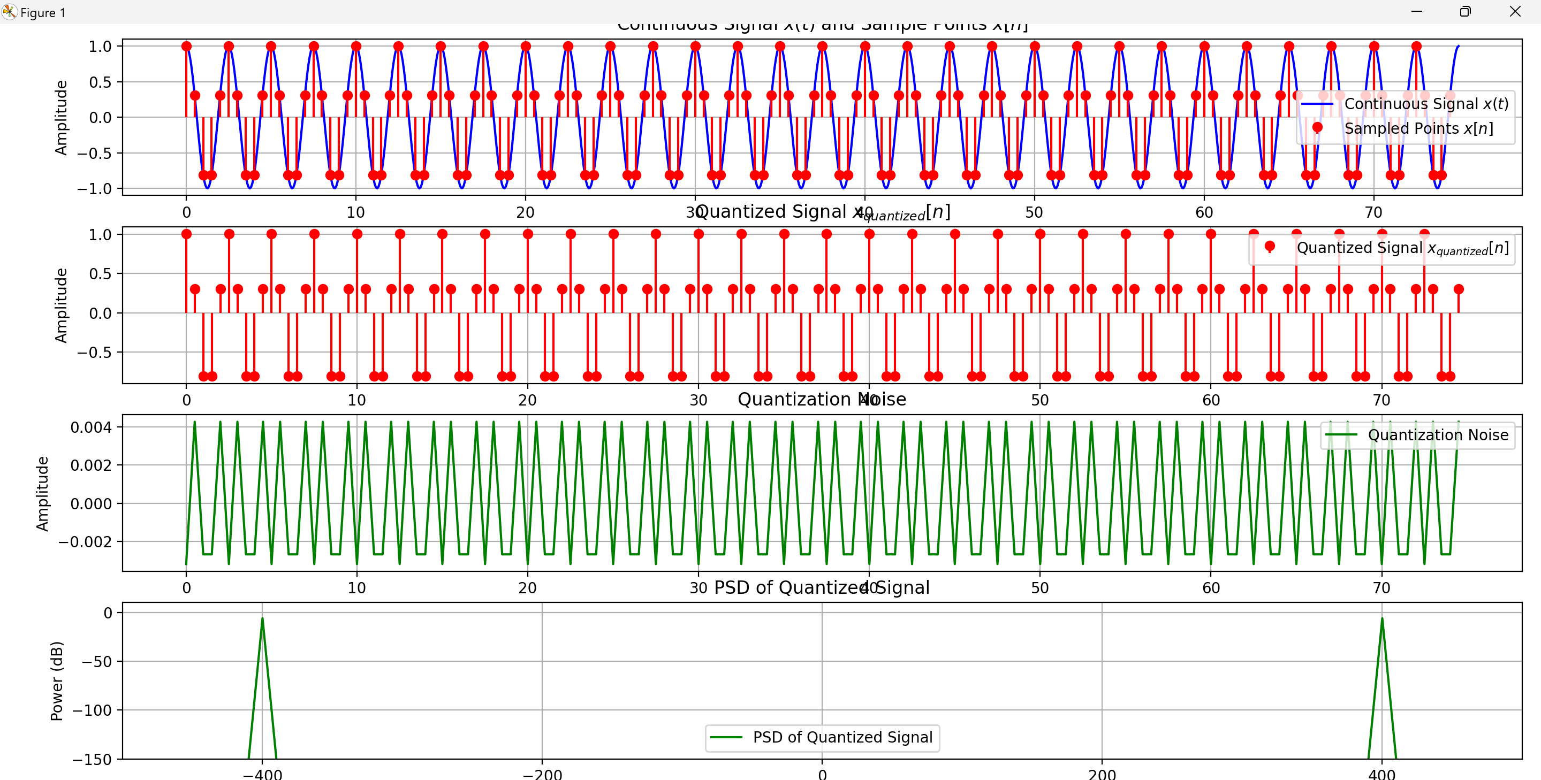

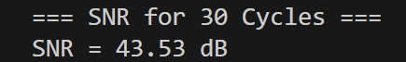

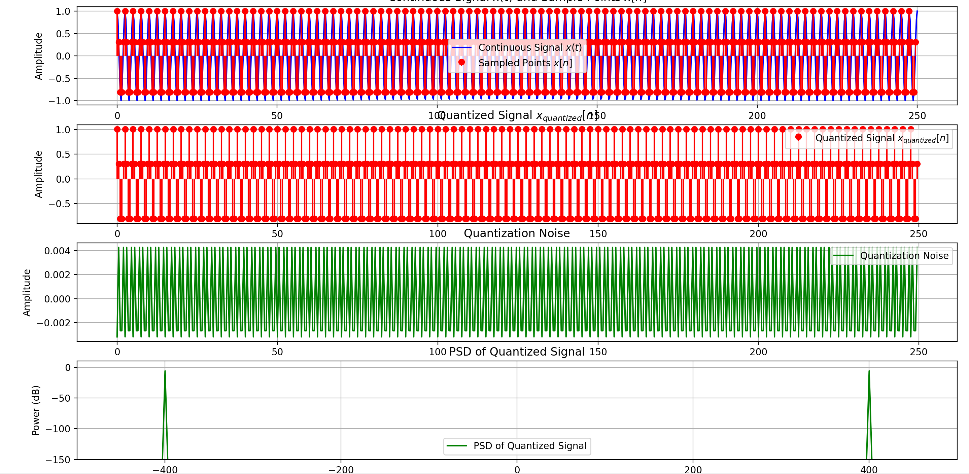

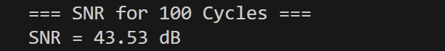

Increasing cycle will make the spectrum clearer (increase N) and more stable, but the amount of calculation will increase. The quantization error repeats periodically: it will cause harmonic distortion (Harmonic Distortion) and make the SNR higher.

b) Find an incommensurate sampling frequency larger than Nyquist rate. Plot the PSD of the new samples. Calculate the SNR from the figure.

Ex: Fs= 1.9G, F0= 400M, Fs/F0=4.75,

N= cycle*4.75= 142.5, DFT int(N)= 142/4.75= 29.89 cycle, Spectral Leakage

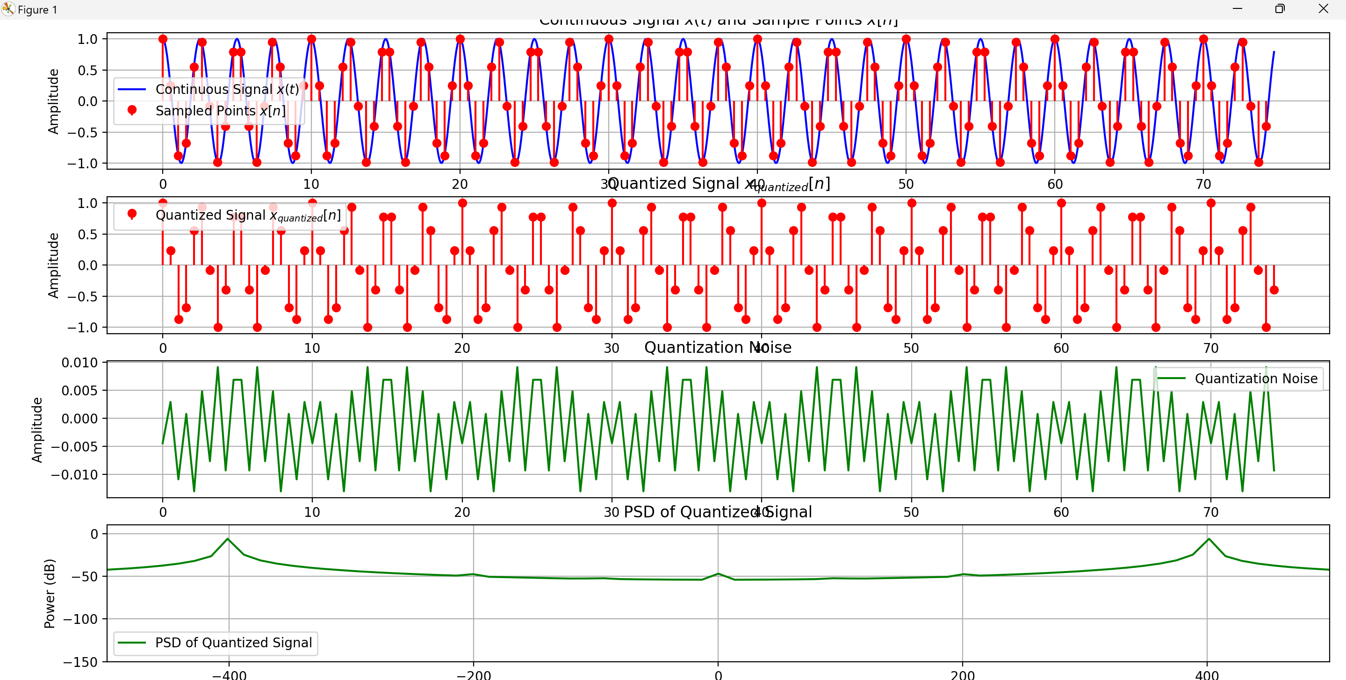



c) Repeat a) using a 12 bit quantizer. Can you prove from simulations that SNR ~ 6N (where N is the number of bits used by the quantizer) in both the cases, N = 6 and N = 12?

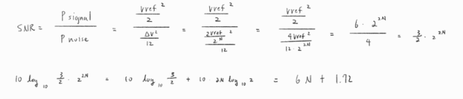

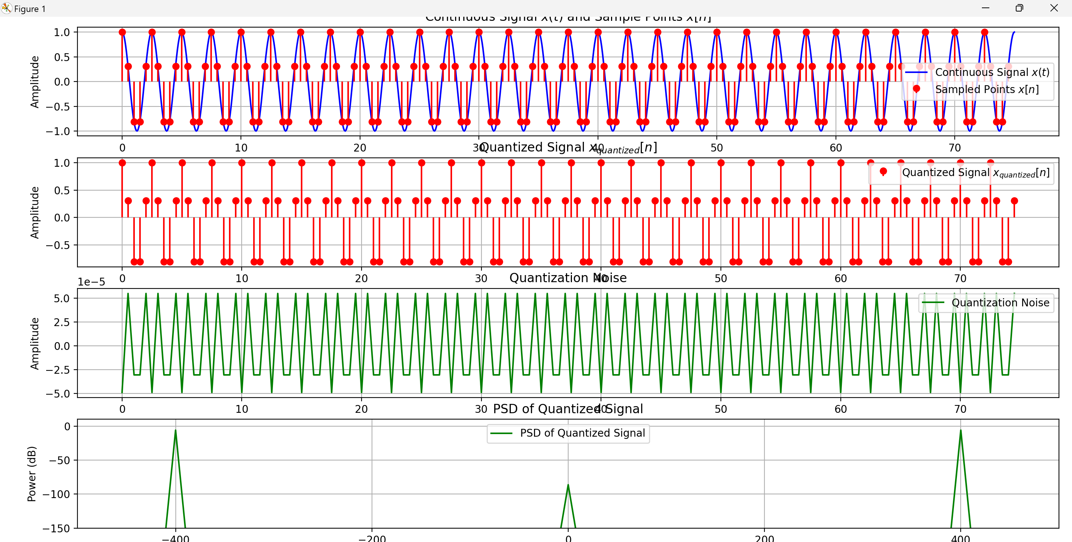



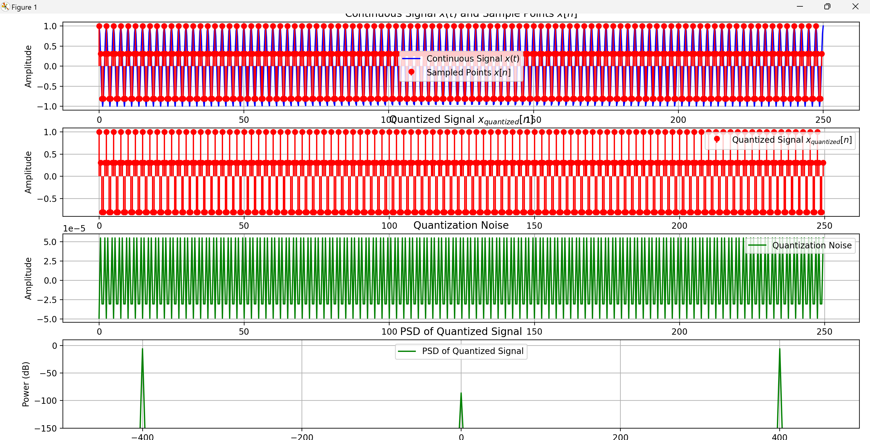



d) Use a Hanning window and repeat c). What is the SNR? Make your own conclusions.

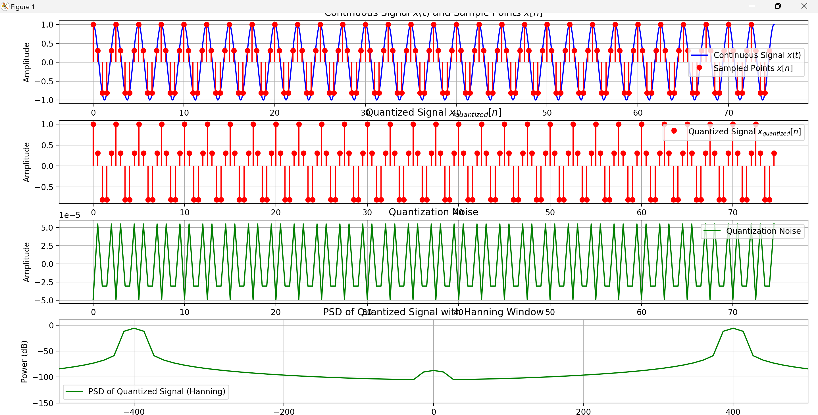



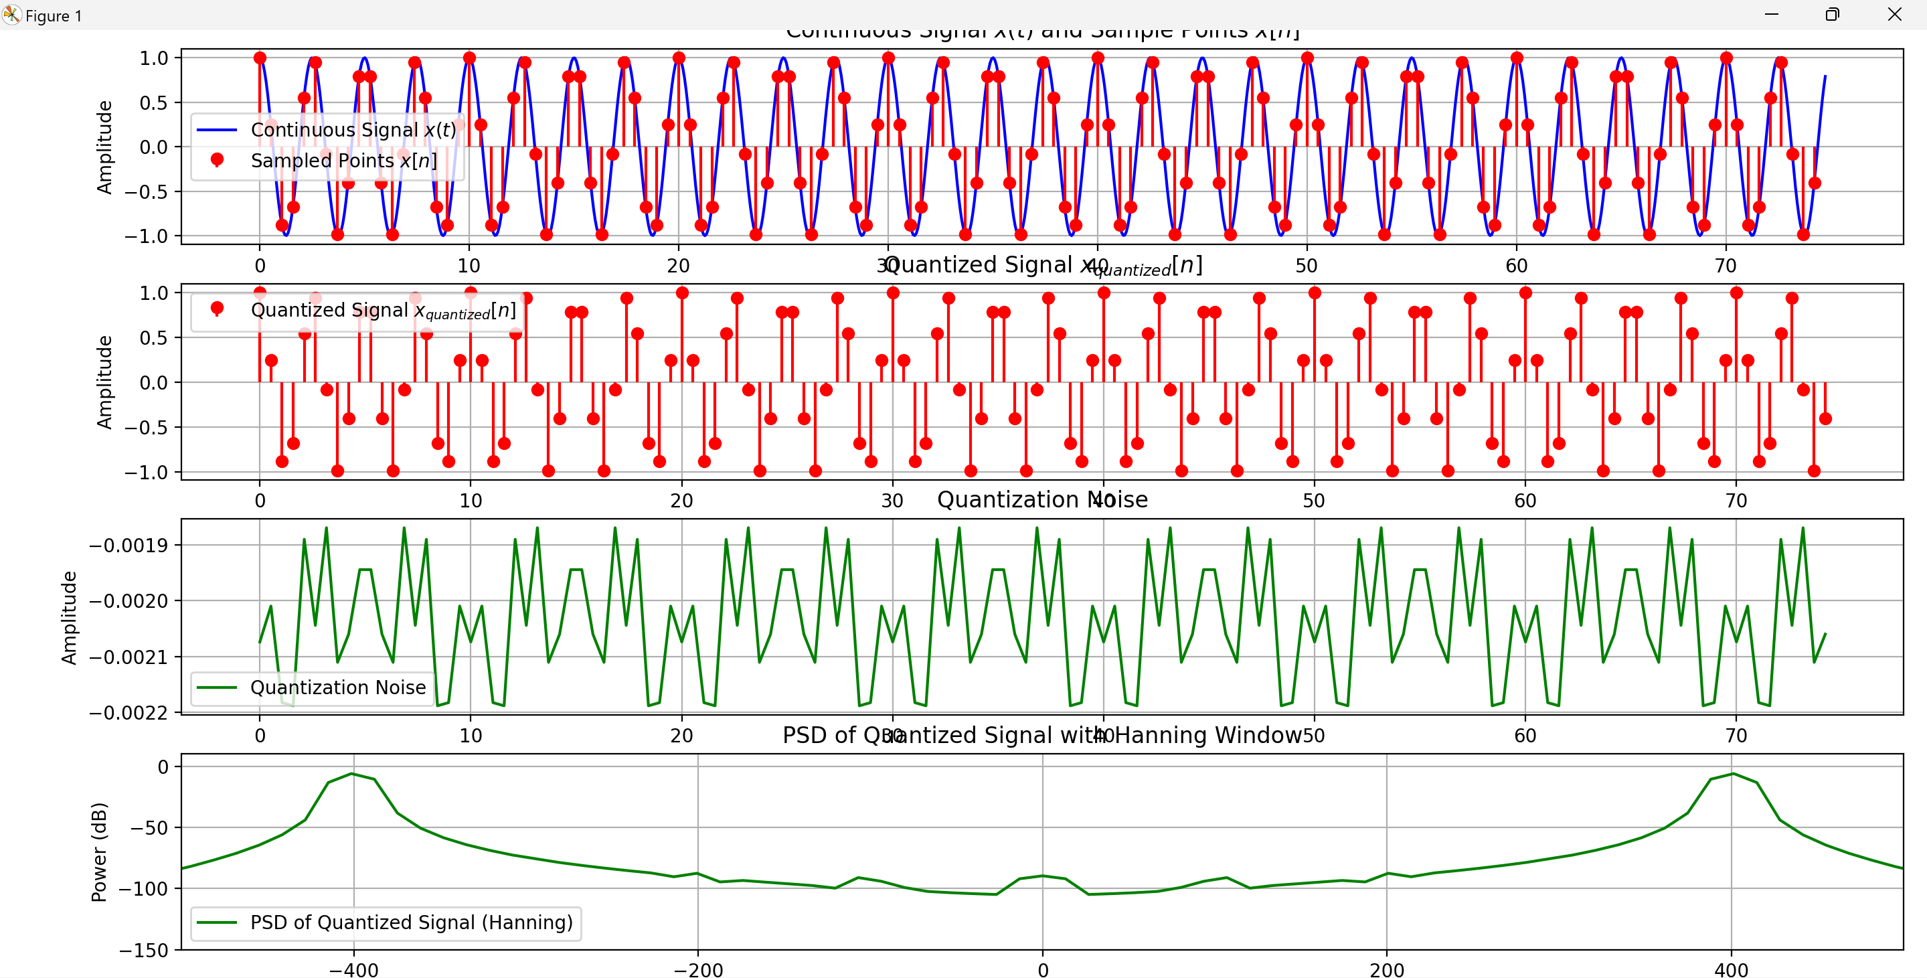



e) Now add noise again so the signal SNR is 38 dB . Repeat c) and d). What are the SNRs? Provide conclusions.

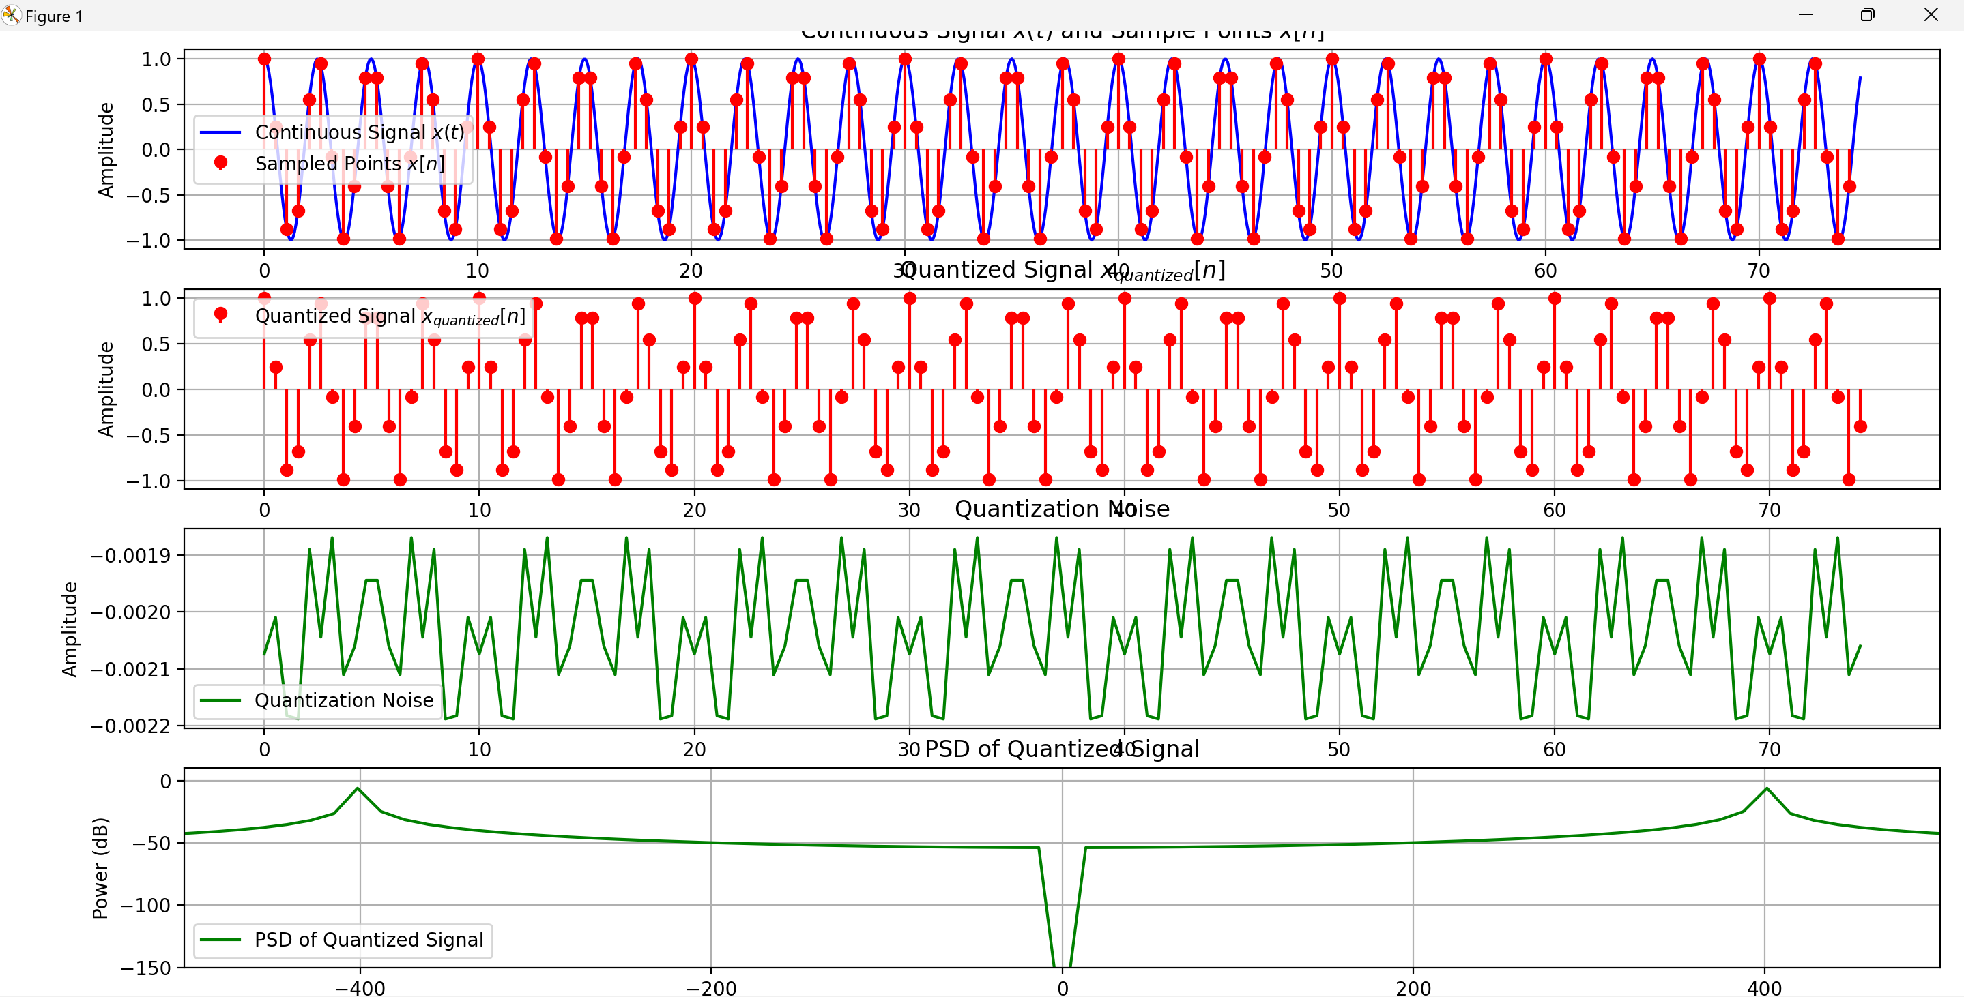



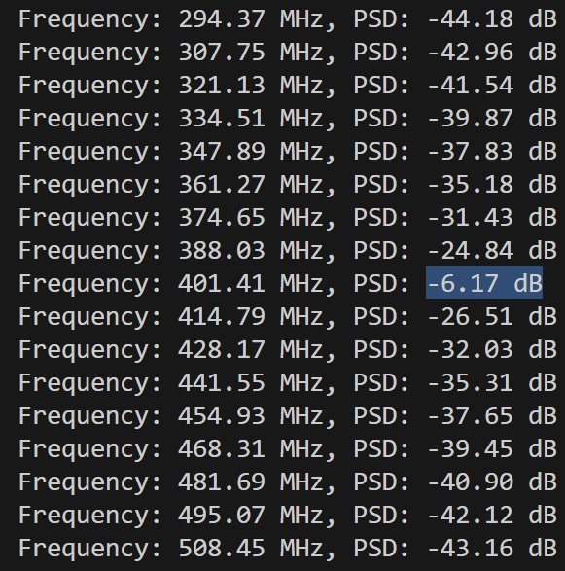 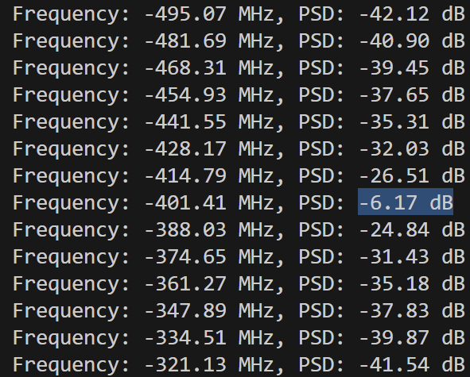

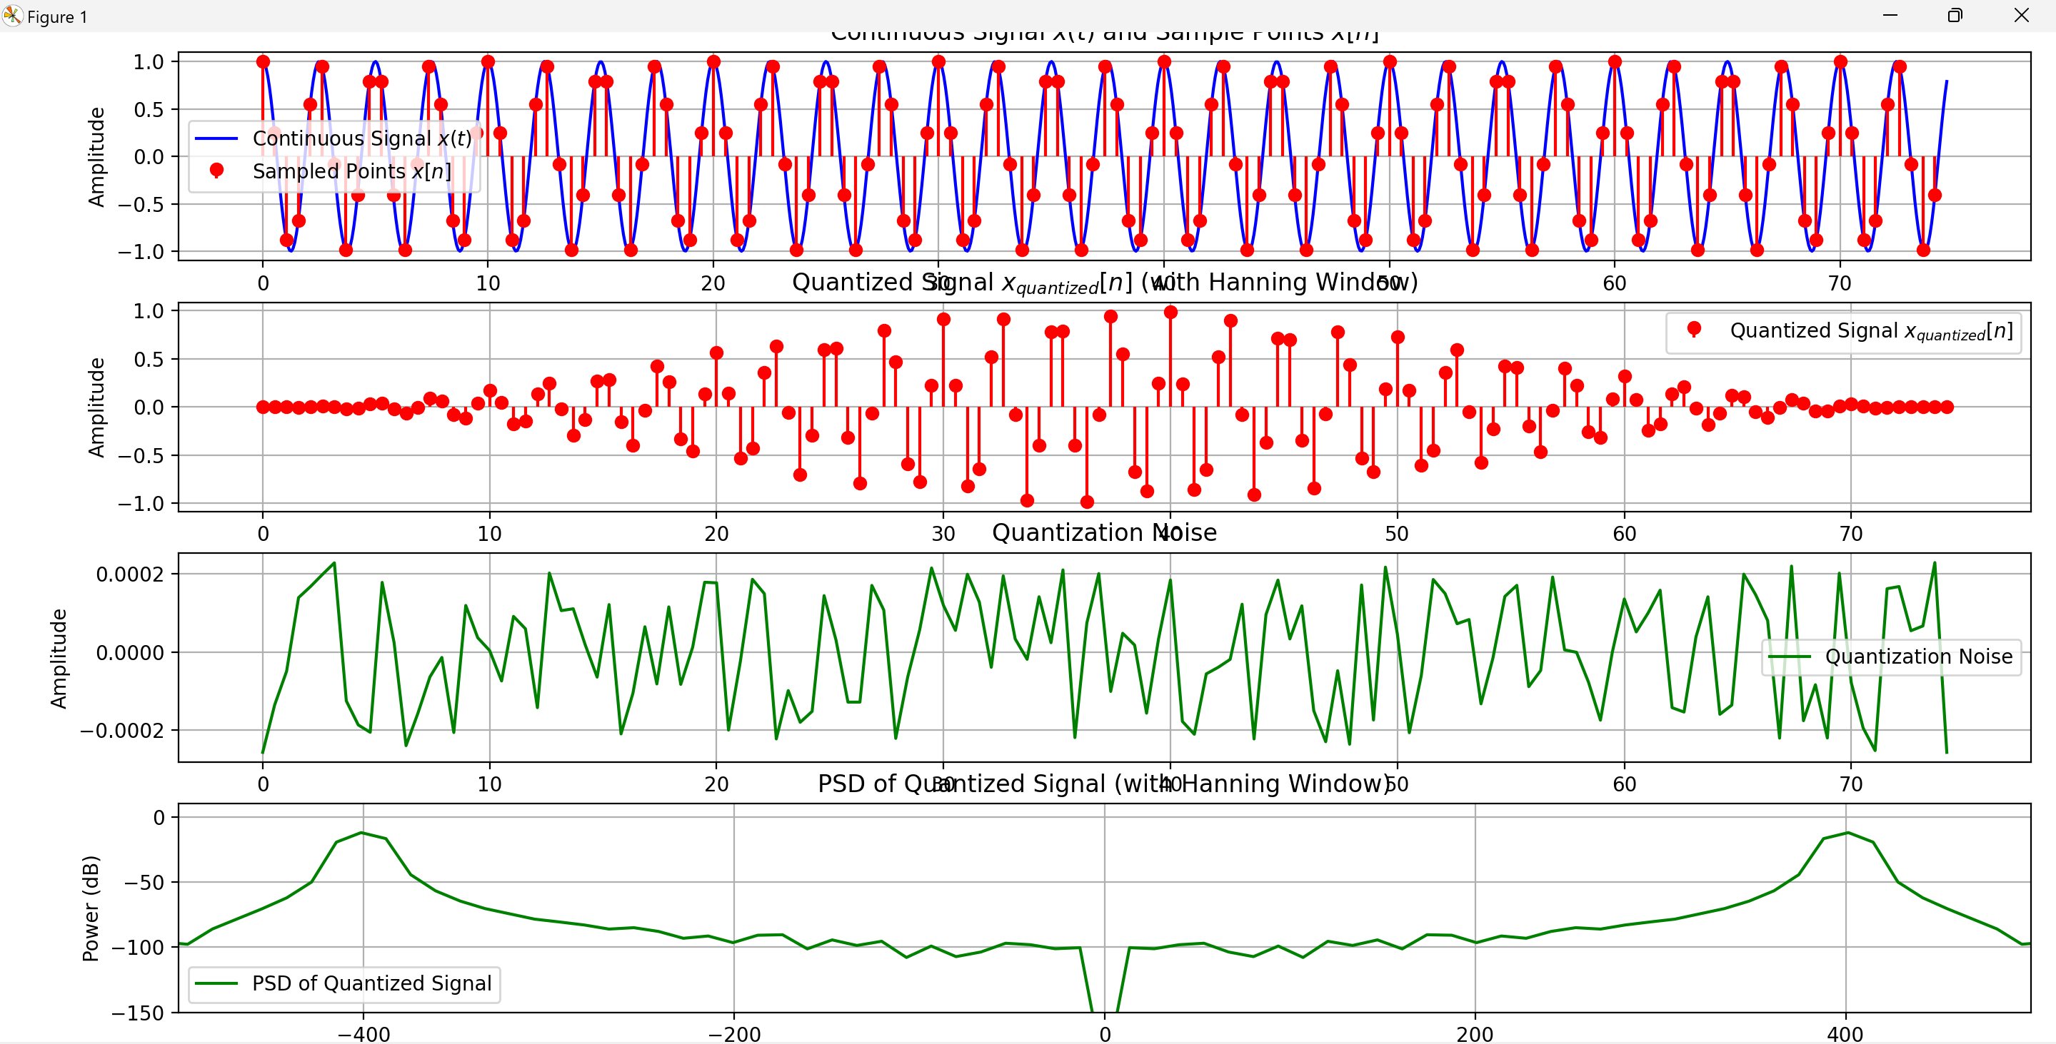



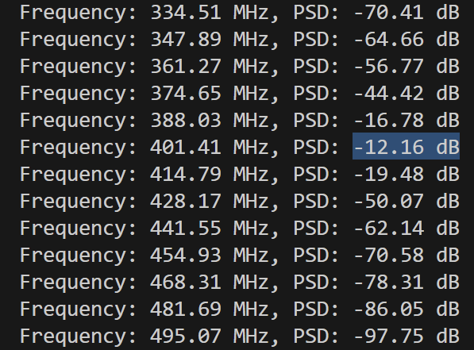 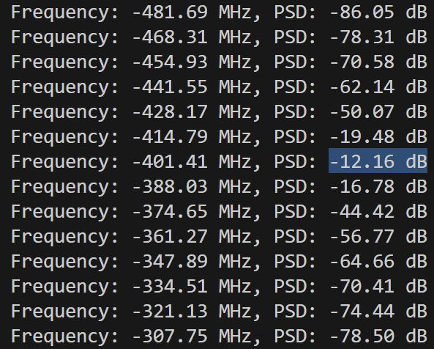

The window will have minor effect on intergrate cycle casue there are no specturm leakage for intergrate cycle

* Appendix

Q1.a PSD noise (without quantization)

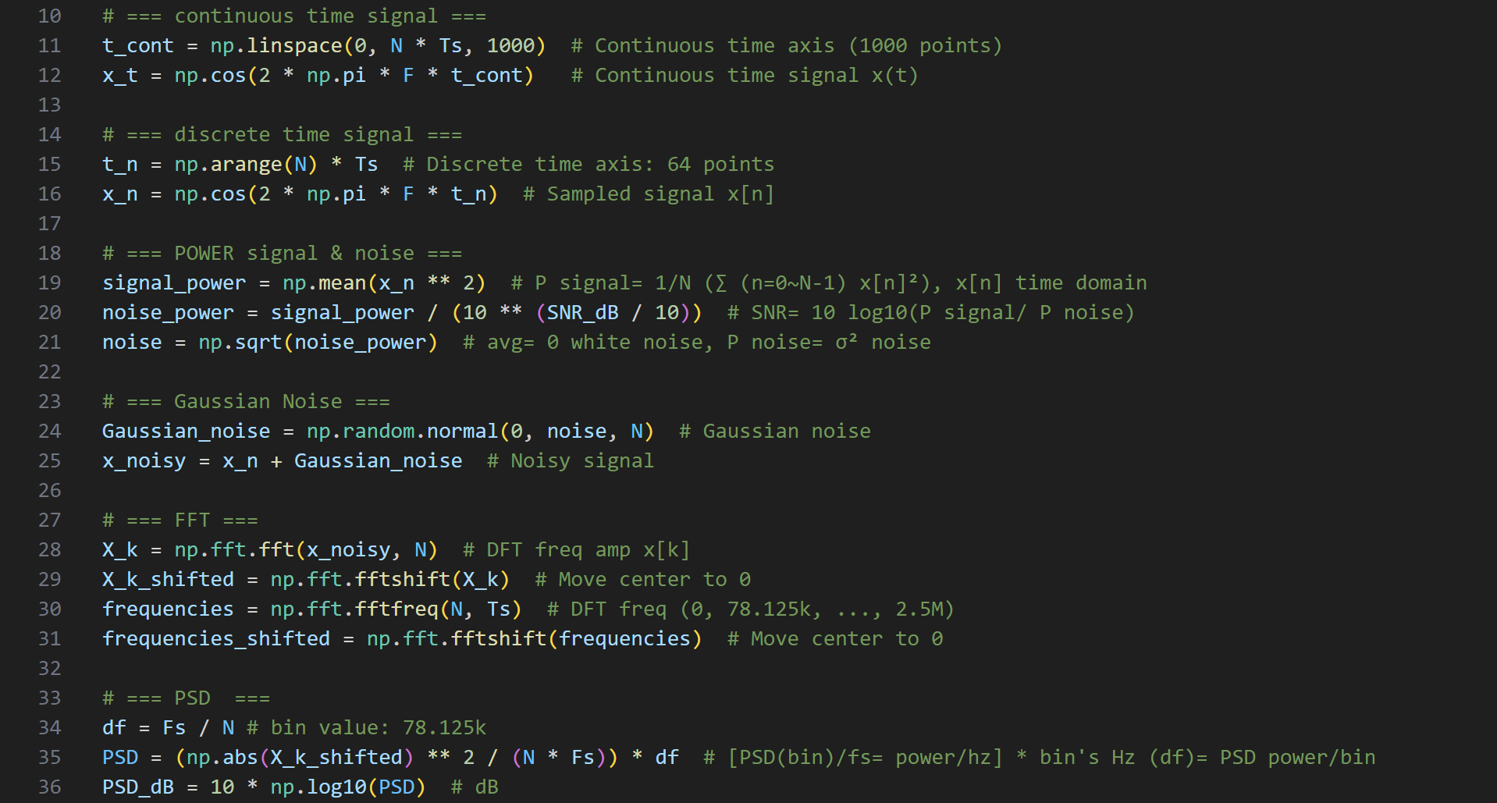

Hanning window

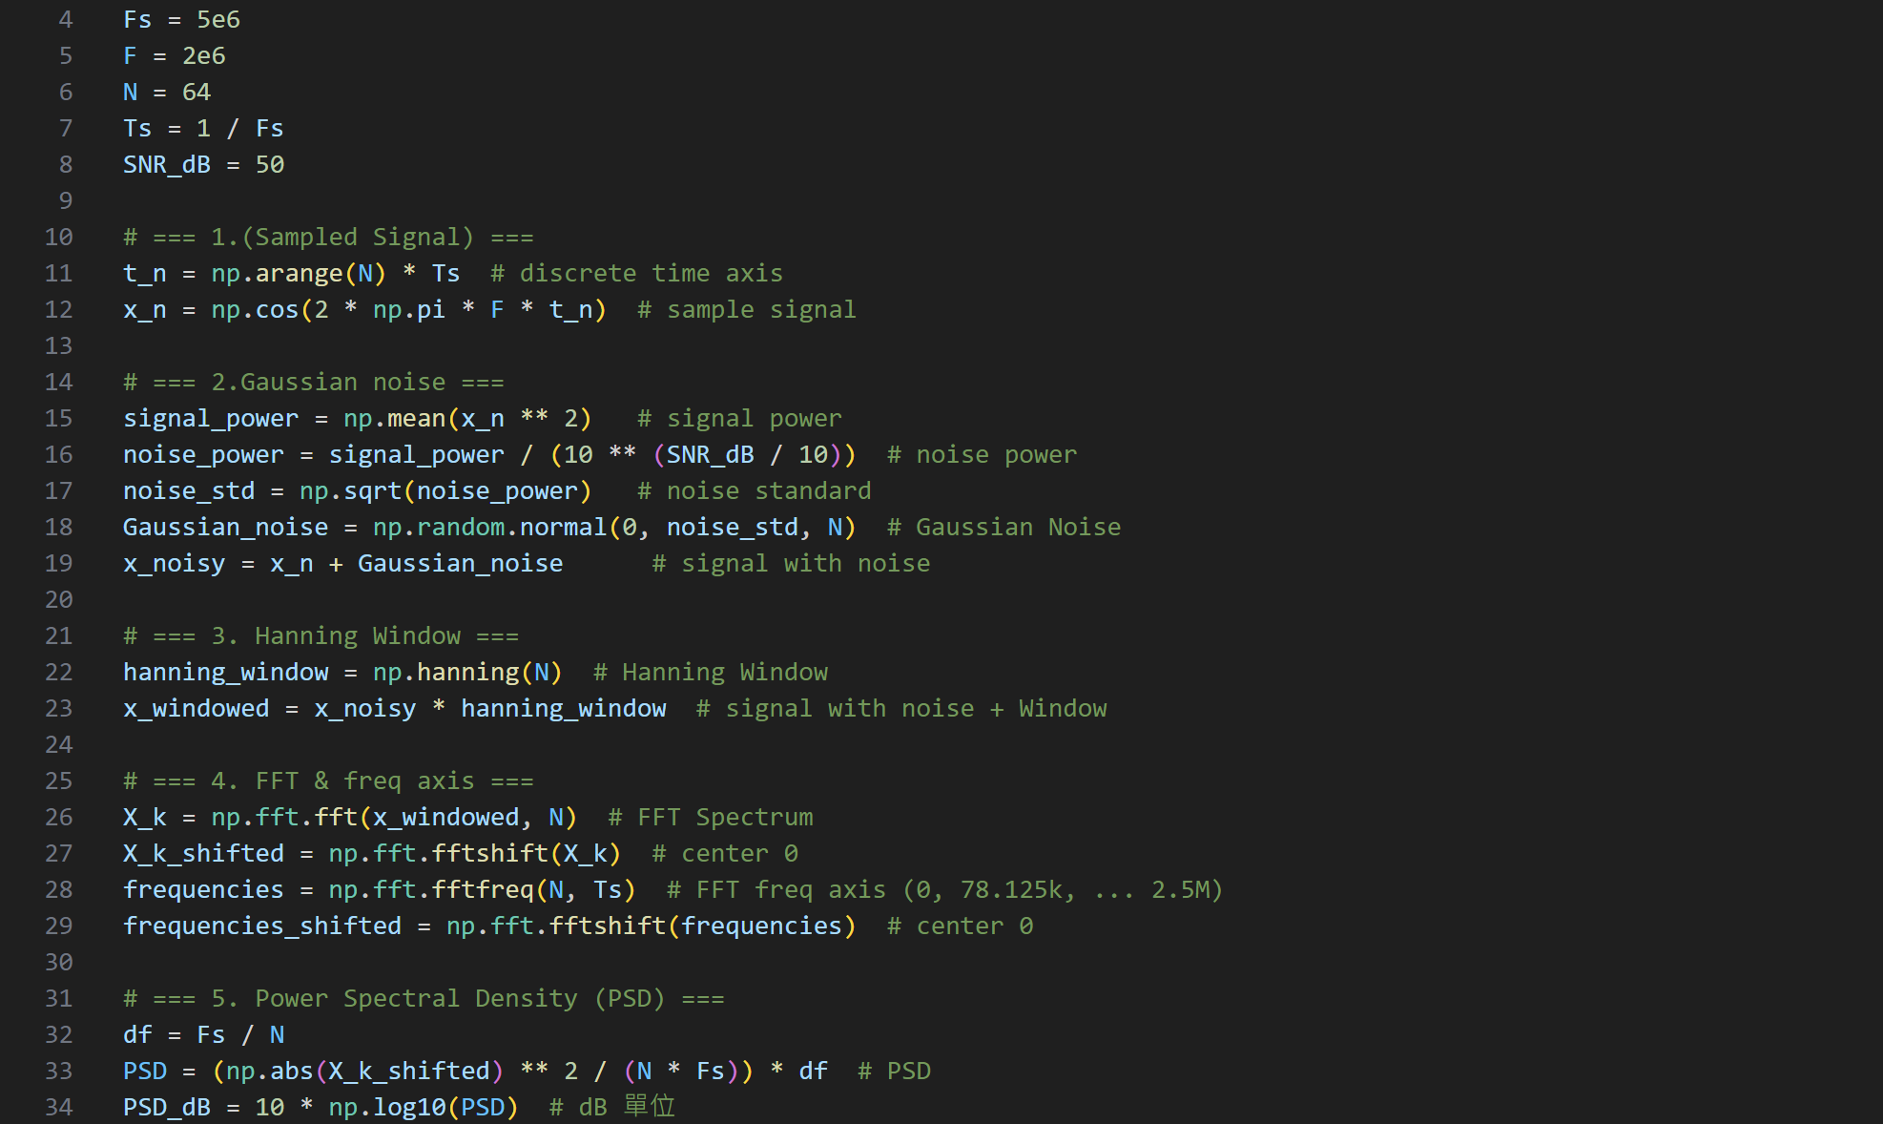

Hamming window



Blackman window



Q2 N cycle

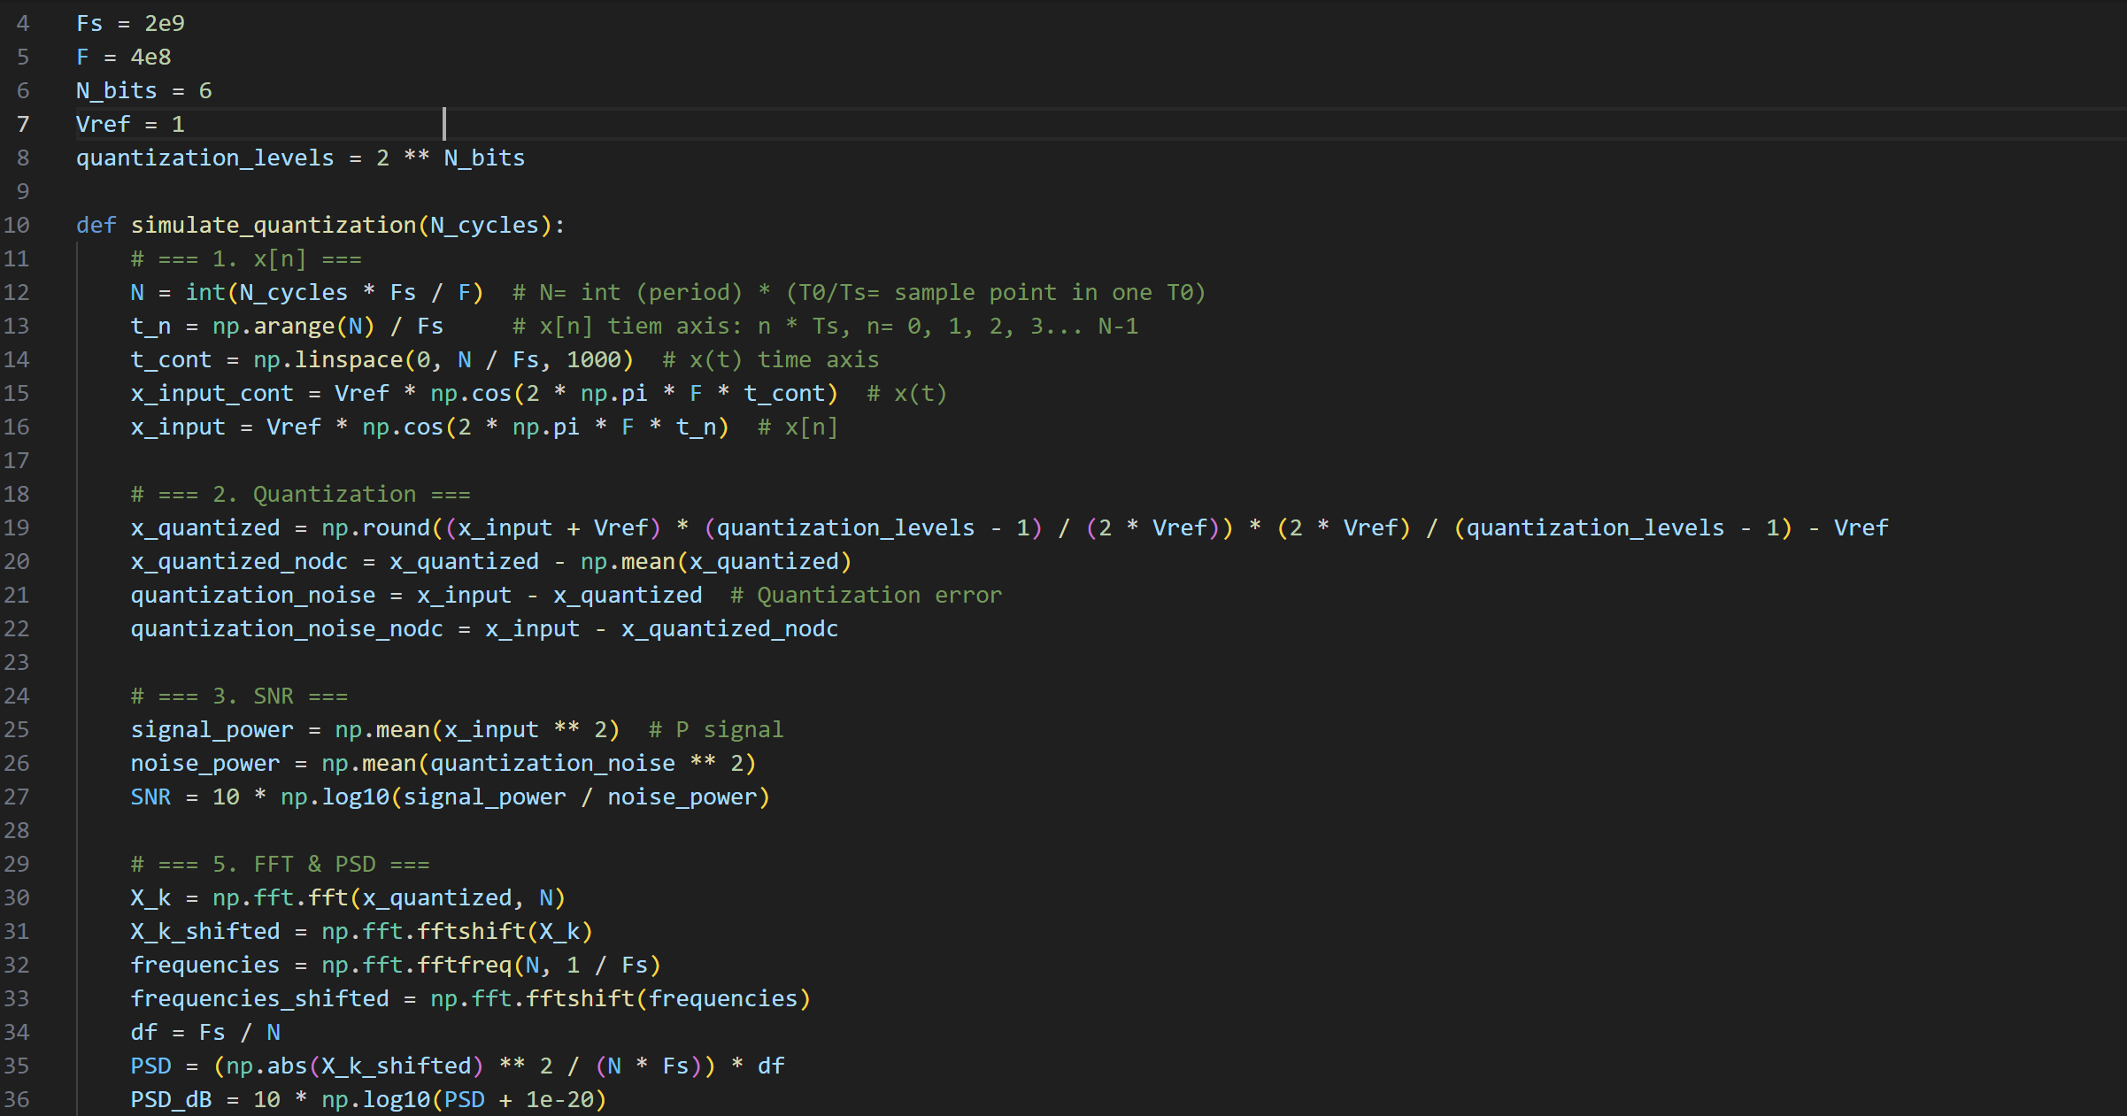

Q2.b not int cycle

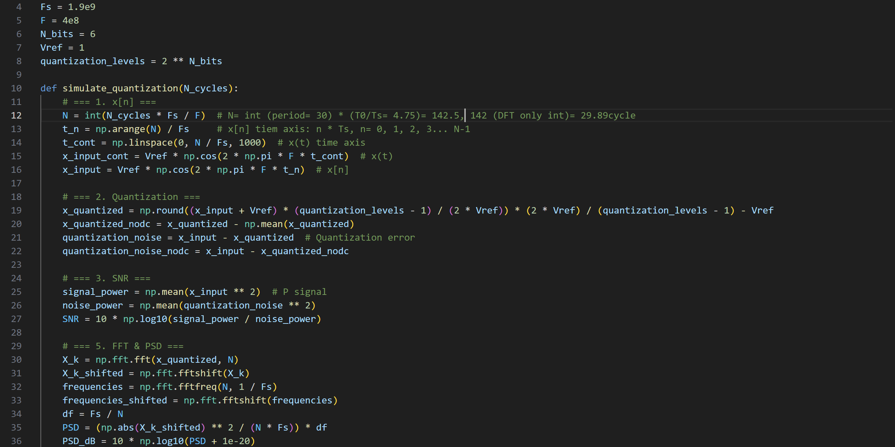

Q2 with window

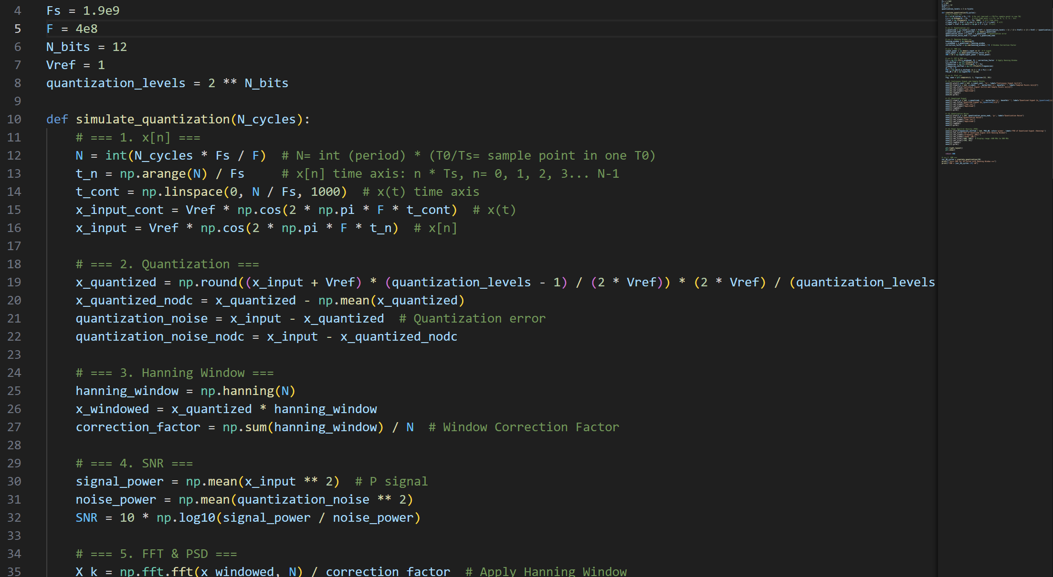

Q2 noise window

